**Week 7_React 9_HandsOn**

**9. ReactJS-HOL**

**app.js**

import React from 'react';

import './App.css';

import ListofPlayers from './ListofPlayers';

import IndianPlayers from './IndianPlayers';

function App() {

  let flag = false;

  return (

    <div className="App">

      <h1>Welcome to Cricket App</h1>

      {flag ? <ListofPlayers /> : <IndianPlayers />}

    </div>

  );

}

export default App;

**ListofPlayers.js**

import React from 'react';

const ListofPlayers = () => {

  const players = [

    { name: 'Virat', score: 90 },

    { name: 'Rohit', score: 85 },

    { name: 'Dhoni', score: 78 },

    { name: 'Kohli', score: 69 },

    { name: 'Raina', score: 55 },

    { name: 'Rahul', score: 88 },

    { name: 'Gill', score: 40 },

    { name: 'Hardik', score: 100 },

    { name: 'Shami', score: 73 },

    { name: 'Bumrah', score: 50 },

    { name: 'Pant', score: 66 },

  ];

  const filteredPlayers = players.filter(player => player.score < 70);

  return (

    <div>

      <h2>All Players</h2>

      <ul>

        {players.map((p, index) => (

          <li key={index}>{p.name} - {p.score}</li>

        ))}

      </ul>

      <h3>Players with score below 70:</h3>

      <ul>

        {filteredPlayers.map((p, index) => (

          <li key={index}>{p.name} - {p.score}</li>

        ))}

      </ul>

    </div>

  );

};

export default ListofPlayers;

**IndianPlayers.js**

import React from 'react';

const ListofPlayers = () => {

  const players = [

    { name: 'Virat', score: 90 },

    { name: 'Rohit', score: 85 },

    { name: 'Dhoni', score: 78 },

    { name: 'Kohli', score: 69 },

    { name: 'Raina', score: 55 },

    { name: 'Rahul', score: 88 },

    { name: 'Gill', score: 40 },

    { name: 'Hardik', score: 100 },

    { name: 'Shami', score: 73 },

    { name: 'Bumrah', score: 50 },

    { name: 'Pant', score: 66 },

  ];

  const filteredPlayers = players.filter(player => player.score < 70);

  return (

    <div>

      <h2>All Players</h2>

      <ul>

        {players.map((p, index) => (

          <li key={index}>{p.name} - {p.score}</li>

        ))}

      </ul>

      <h3>Players with score below 70:</h3>

      <ul>

        {filteredPlayers.map((p, index) => (

          <li key={index}>{p.name} - {p.score}</li>

        ))}

      </ul>

    </div>

  );

};

export default ListofPlayers;

**index.js**

import React from 'react';

import ReactDOM from 'react-dom/client';

import './index.css';

import App from './App';

const root = ReactDOM.createRoot(document.getElementById('root'));

root.render(

  <React.StrictMode>

    <App />

  </React.StrictMode>

);

**OUTPUT:**

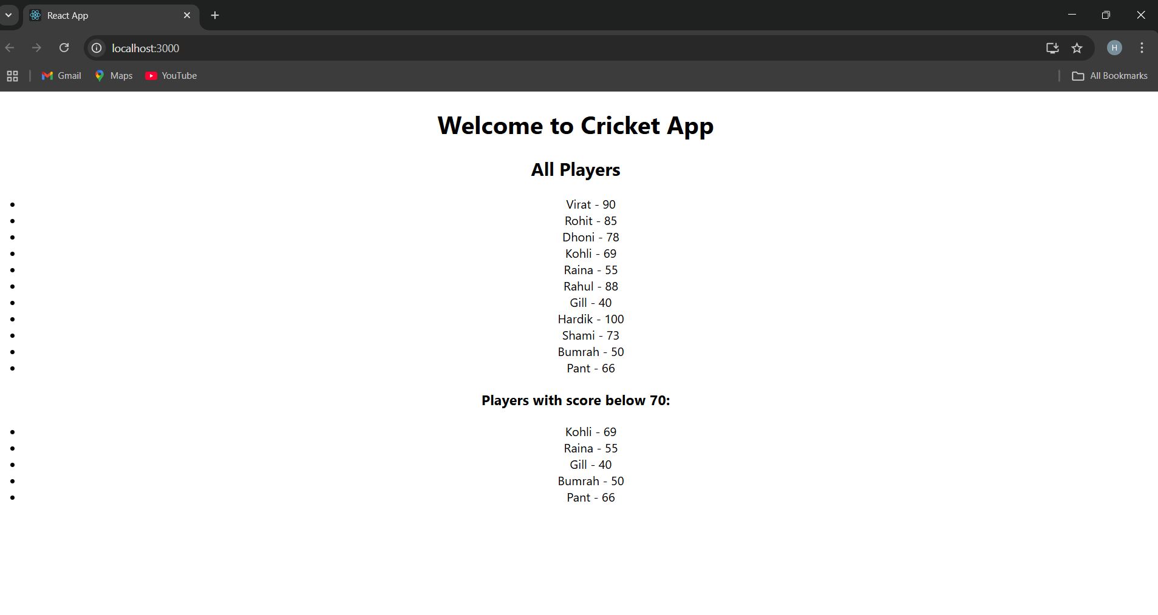

**When flag=true**

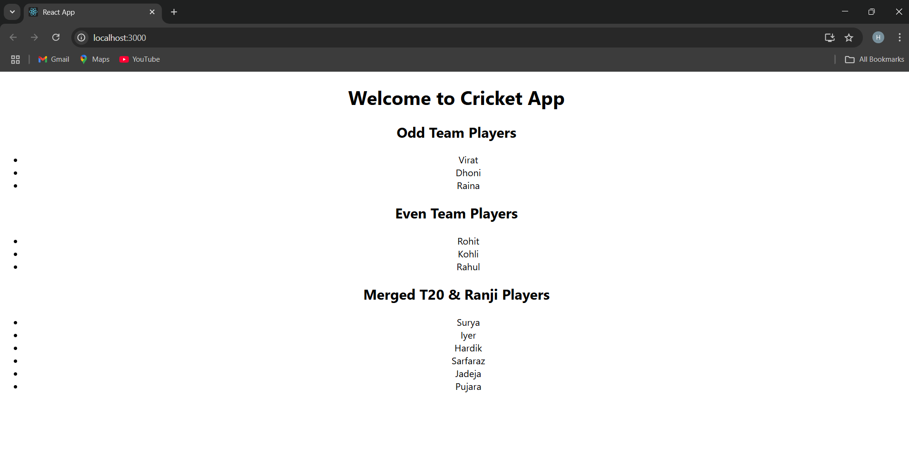

**When flag=false**